Create a custom docker image for nginx and deploy it using docker-compose, where the volume bind mount should be at /var/opt/nginx location. Push the created custom docker image to your docker hub.

**First, we are going to create a docker file:**

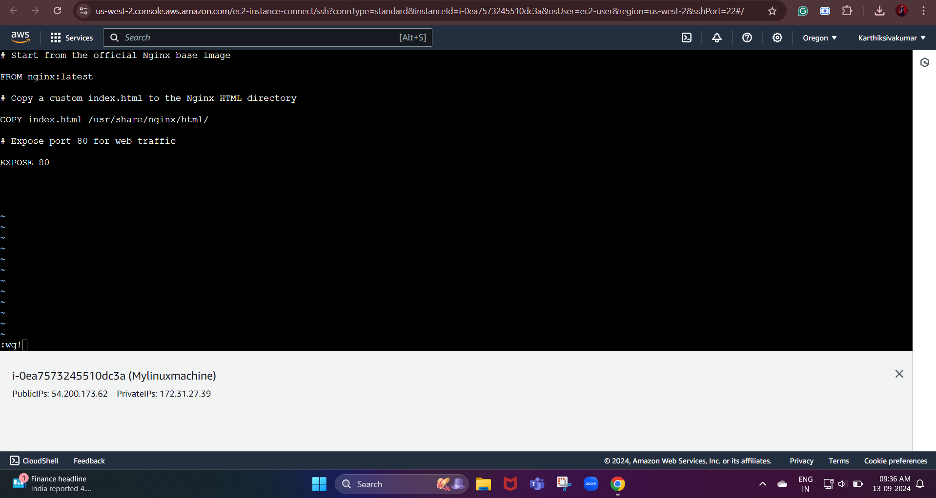

**Now, we edit our docker file with our custom Nginx configuration.**

Next, we are going to create a simple HTML file

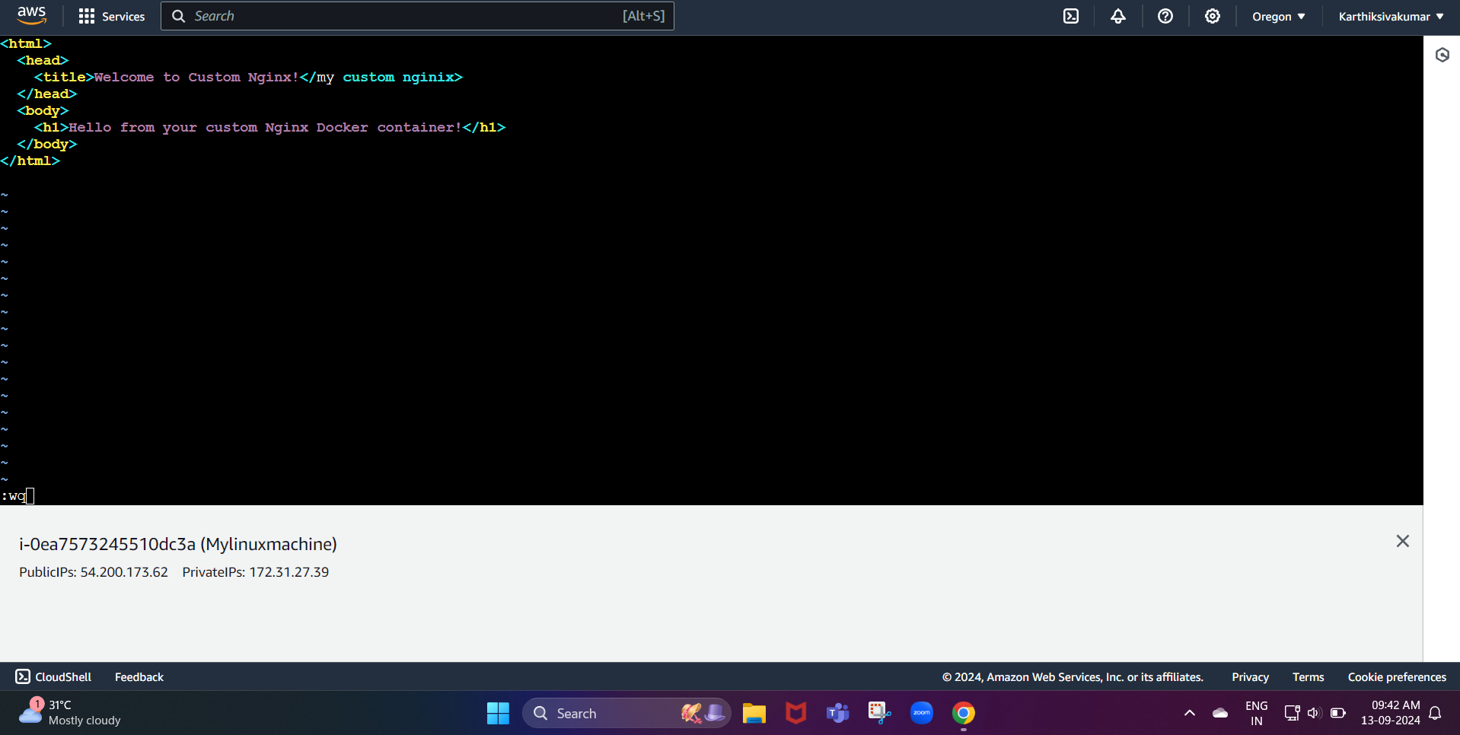

Now, the sample index.html file has been created

Next, we need to build a docker image

Now, we are going to build the image:

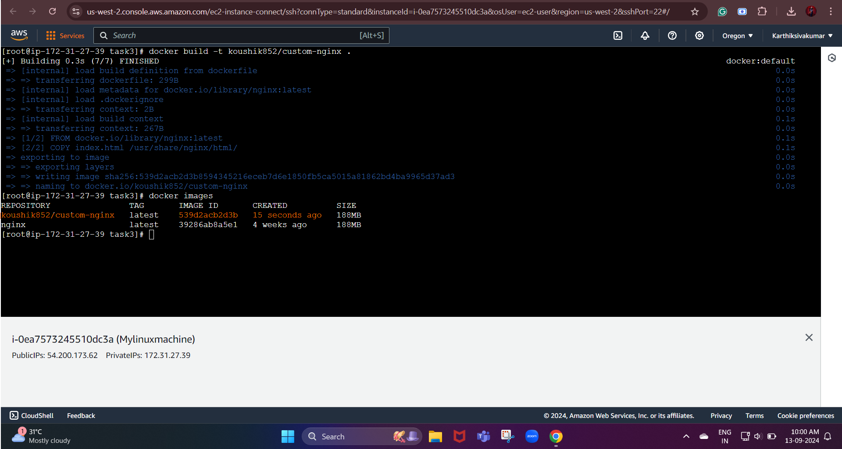

Command: docker build -t koushik852/custom-nginx .

**As per the question, we are going to deploy the custom Nginx image by using the docker-compose:**

First, we are going to edit our docker-compose.yml file we need to create this in the same directory.

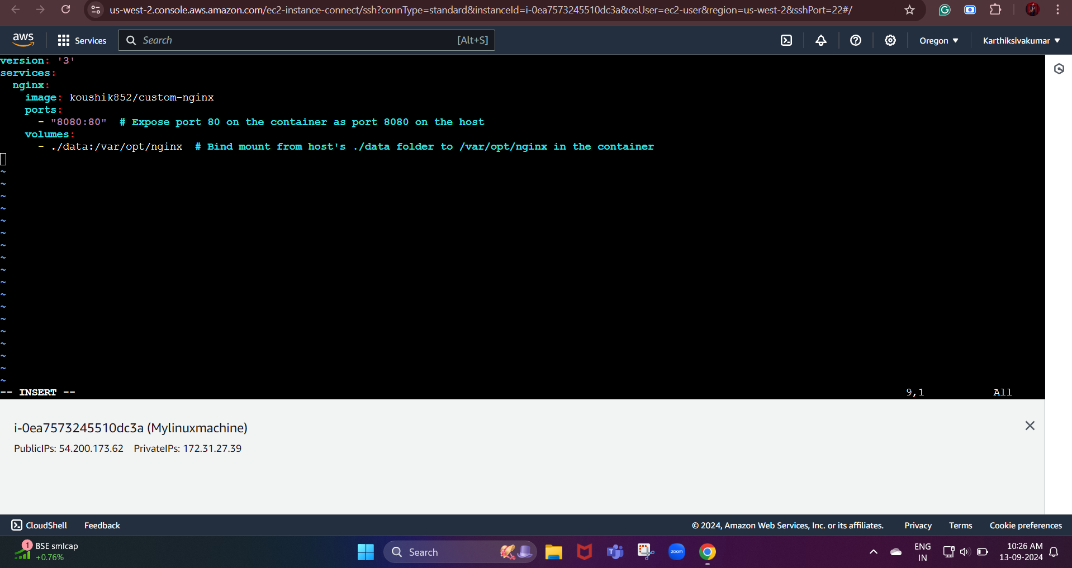

**Now, we need to create a directory for bind mounting**

After this, we need to run the docker-compose to run the Nginx container

command: docker-compose up -d

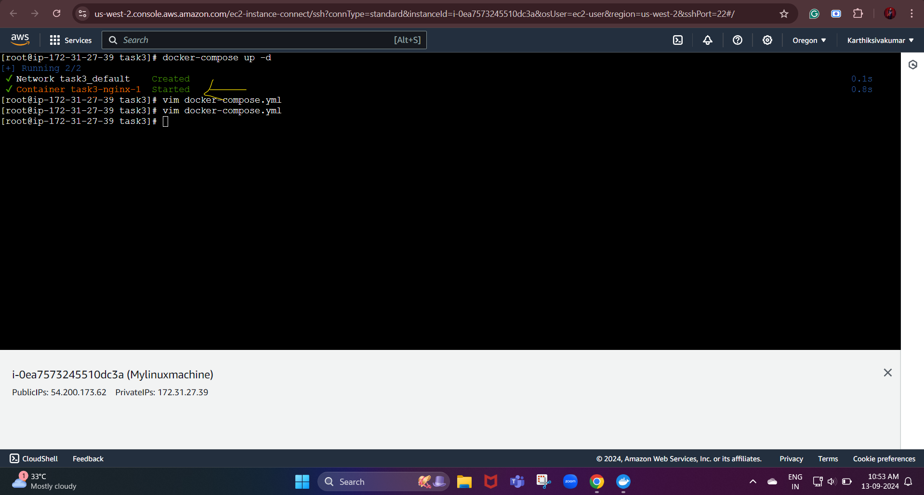

Finally, we need to push the custom docker image to the docker hub

Command used:

* docker login
* docker tag koushik852/custom-nginx koushik852/custom-nginx:latest
* docker push koushik852/custom-nginx:latest

latest: digest: sha256:94b0d5780db03ce5502e15abc5533aafd5e76302401ce8ced2c50eaf1112ec3f size: 1985

